Design Review

Date: October 2, 2013

Author: Fanxing Meng

Reviewer(s): Weiye Wang

# Original Design

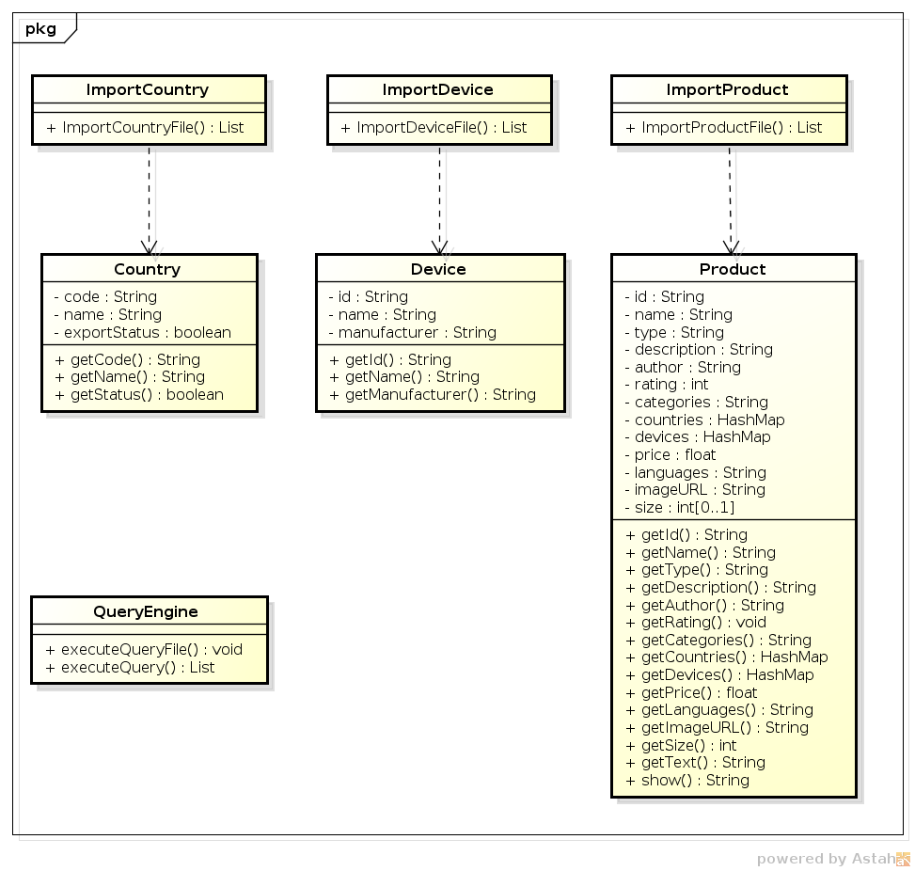

# Comments

Based on this early version of design, a couple of issues emerged in the review session:

1. The list of countries, devices and products would have to be declared and stored in the TestDriver class as there is no central storage class in this package, through which the import procedures can only be done in a one-time fashion and does not give good modularity and a friendly interface.
2. The three importer classes only contains one method each, which does pretty much the same thing. These methods can be combined into a single importer class.
3. Using lists to store information requires O(n) search time for each query which is not efficient.
4. Using Hash Maps to store country and device information in unnecessary in products as the content (values) will never be needed in queries.
5. The managing capabilities of maintaining the database is low in that it is only capable of adding entries from files but not updating or deleting entries, or doing any of these by command input.

# Changes

1. The three importer classes were merged into a single importer class with three methods for each type of data. Data field entries are now being examined for validation.
2. Data storage and updating are now incorporated with the following three classes: CountryData, DeviceData, and ProductData. They have built-in methods to populate and replace entries in a singleton Hash Map for each type of data. The keys are country codes, device IDs and product IDs using their uniqueness property while the values are all other information packed into Lists or another class instance.
3. In the Product class, countries and devices fields are now Strings for easier storage and retrieval.

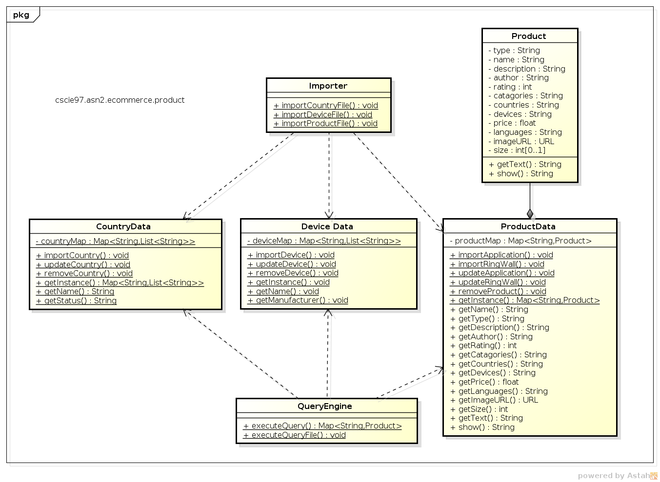

# Summary

The design document provided a structural starting point for the implementation, but lots of interface improvements can only be made during the implementation and testing procedure.

The requirement could have had more method that are to be supported, and internal connections required for the different modules to cooperate because in current design the device information does not interfere with any other component and one would wonder why this piece of data has to be supplied in the first place.

The review part is crucial in that it serves as a minor iteration that could help to point out some design flaws and unrealistic assumptions in advance so as to save work. But this requires an experienced programmer to conduct this evaluation conceptually without implementing and debugging.